CPRIAN TOROITICH-134688-ICS B

DIFFERENCES BETWEEN THE TCP/IP AND OSI MODELS

* The OSI model is a generalized model that is based on each layer's features. The protocol-oriented standard is the TCP/IP model.
* The three ideas, namely facilities, interfaces, and protocols, are distinguished by the OSI model. In these three, TCP/IP does not have a strong distinction.
* The OSI model offers guidance for how communicating has to be handled, while the interface specifications of TCP/IP protocols are established on the Internet. So a more realistic model is TCP/IP.
* In OSI, first the model was developed and then the protocols were developed in each layer. First the protocols were developed in the TCP/IP suite, and then the model was developed.
* The OSI has seven layers while the TCP/IP has four layers.
* The TCP/IP model is a client server model used for transmission of data over the internet while the OSI model is a theoretical model which is used for computing system.
* TCP/IP expands to transmission control protocol/ internet protocol while OSI expands to open system interconnect.
* TCP/IP model obeys the Horizontal approach while ISO model obeys the Vertical approach.
* TCP/IP model was developed by Department of Defense (DoD) while the OSI model was developed by the ISO (International Standard Organization).
* For any network, even the Internet, TCP/IP is a regular protocol, while OSI is not a protocol, but a reference model used to recognize and build the system architecture.
* TCP/IP follows top to bottom approach, whereas, OSI Model follows a bottom-up approach.
* TCP/IP is Tangible, whereas OSI is not.

Diagrammatic Comparison

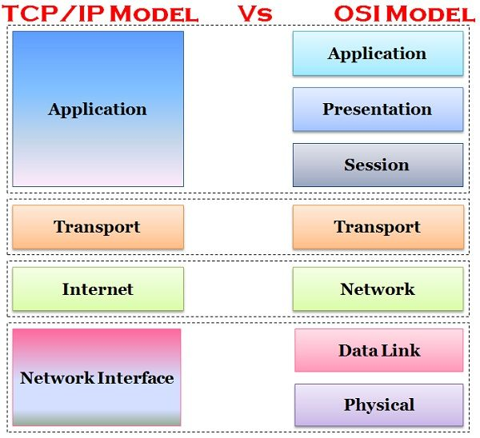

REFERENCES

* Maathuis, I., & Smit, W. A. (2003, October). The battle between standards: TCP/IP Vs OSI victory through path dependency or by quality?. In *ESSDERC 2003. Proceedings of the 33rd European Solid-State Device Research-ESSDERC'03 (IEEE Cat. No. 03EX704)* (pp. 161-176). IEEE.
* Maathuis, I., & Smit, W. A. (2003, October). The battle between standards: TCP/IP Vs OSI victory through path dependency or by quality?. In *ESSDERC 2003. Proceedings of the 33rd European Solid-State Device Research-ESSDERC'03 (IEEE Cat. No. 03EX704)* (pp. 161-176). IEEE.